Supply Chain Management
- Recap: challenge of growing a network is how do you continue to deliver standardised quality levels
- Newsvendor problem: one shot of printing a newspaper, can’t overprint or underprint.

Supply chain introduction

Importance of supply chain management
- Final product is not the sole achievement of the OEM (original equipment manufacturer)
  - Supply chains are a key source of cost (75%), risk, innovation, quality and value
  - Customer experience is therefore determined by the supply chain, not 4 Ps
    - Walmart use monopsony power create dependence, then drive down prices
- Supply chains are connected systems; competitiveness of one tier is a function of the supply and distribution functions of the surrounding tiers
  - “Value Chains compete, not individual companies!” (M Christopher)

What is a supply chain?
- A supply chain is all parties inside and outside company that enable the delivery of a product or provision of a service to the end customer.
  - This includes manufacturers, suppliers, transporters, warehouses, retailers and even customers. This is cross-functional e.g. operations, marketing, finance, marketing etc
  - Also called value chain (Porter, 1985) or value stream (Lean Thinking, 1990)
- We are concerned with the management of flows through the supply chain
  - Information flow (orders, schedules, forecasts) is the pacemaker
  - Material flow is the shipments against the orders
  - Additional flow incudes payments and exchange of technical information
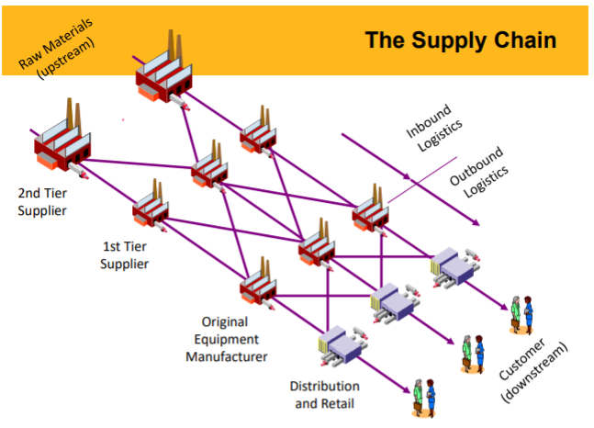
- OEM’s direct suppliers are tier 1, and they send their production to distribution and retail who then send to customers.
  - Visibility drops off after tier 1 suppliers; firms aren’t sure who they’re dealing with.
  - Created an issue during covid for firms who were usure what their exposure was further down the supply chain

Managing supply chains
- Venn diagram of sourcing, operations (manufacturing) and logistics (materials management).
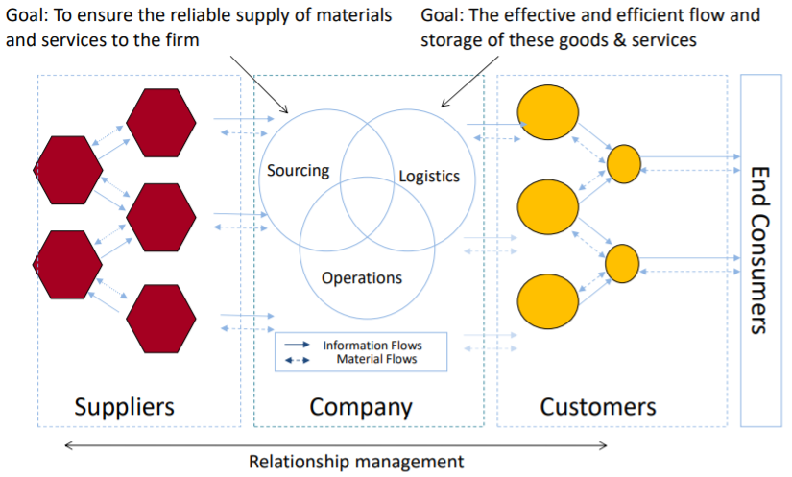
  - These functions coordinate the flow of information and materials within the firm, and then must cross organisational boundaries (upstream to customers, downstream to suppliers)
- Gaps between functions here:
  - Sourcing is about the reliable supply of materials and services to the firm, and its KPIs are mainly around cost. Natural bias toward low-cost drives outsourcing
  - Logistics is about ensuring the effective and efficient flow and storage of goods and services. What mode of transportation, where should facilities be located, when should we distribute, in what form should we store inventory?
    - Focus is availability and meeting customer requirements, can create a tension with sourcing focus.

Operations management vs supply chain management
- Operations management is internal, focused on focal firm only, optimising intra-firm processes, sees information as an asset which should not be shared with other companies
- Supply management is about managing inter-firm processes to maximise value to the customer, focused on the dynamic interplay between firms. Sub-optimisation of the operation at the local firm to support the holistic strategy (Zara distribution).

The Bullwhip effect
Structure drives system behaviour – The “Bullwhip Effect”
- A by-product of the global supply chain system.
- Oscillations of “feast and famine”, with the effect magnifying the further upstream we go
- The fundamental problem of unmanaged supply chain; where you have multiple decision tiers (multiple parties making order and production decisions), some uncertainty around customer demand,
- Causes:
  - Multiple decision tiers
  - Uncertainty via a lack of communication and demand signalling
  - Batching and large ordering
  - Shortages and gaming?
  - Delays of material and information further up the chain, e.g. knowledge about prices. Low prices pull forward demand, high prices might postpone demand. So we want stable prices (Tesco and other supermarkets want price stability to create demand stability).

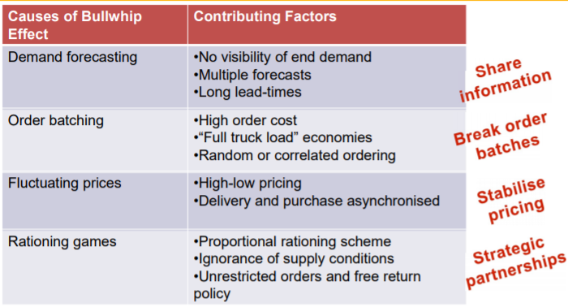
Mitigating the bullwhip effect

Other supply chain challenges
- Global supply chains with long lead times.
  - Bullwhip effects
  - Blockchain exploits a lack of trust, it proxies trust
- Rising and shifting customer expectations
  - Order winners become order qualifiers; customer expectations don’t backslide they just keep ratcheting up
  - Increasing demands can strain supply chains and the workers (iPhone 5)
- Increasing labour costs in lower cost regions
  - Global supply chains built on labour cost arbitrage; aggregate productivity is greater
- Changes in logistics costs
  - Transportation costs drive decisions e.g. oil costs rising.
  - Transport costs a function of capacity as well as oil prices – EoS game.
- Increasing supply chain risks
  - Covid-19 75% of US companies had parts shortages in March 2020
  - Usually disruptions are regional and only affect the supply side
- Sustainability
  - Social responsibility and environmental concerns tied together
  - Keeping illegal inputs out of the legitimate supply chain
  - Problems can be systemic and hard for any one company to solve
- Volatility
  - Trade wars, Japan v S. Korea and USA v China
  - These create currency movements, impediments to trade and changes in taxes which affects sourcing decisions
- Digitalisation of supply chains – industry 4.0 affect SCs as well as ops

Solutions to these problems

Lean supply chain management
- Traditional paradigm – vertical integration, control through ownership and arm’s length relationship with suppliers.
  - Lean paradigm – own core competence, but achieve control through close relationships w supplies
- Key aspects of lean SCM – micro level:
  - Integrated supplier lead times and delivery schedules
  - Inventory flows from supplies pulled by customer demand
  - Level production schedules to avoid spikes in supply chain
  - Effective two-way communication links
- Relationship management level of SCM:
  - Big autos used market power to squeeze suppliers on price to stay afloat during recessions.
  - Toyota and Honda focused on succeeding as a supply chain, working together instead of grabbing more of the pie
  - Illustrated in supplier development – go into supplier plants and address idiosyncratic production problems of the supplier (quality, throughput time, etc).
    - GM does the same, but then takes all cost-savings, whereas Toyota shares savings equally.
    - Shift toward Toyota’s philosophy after recessions as the supply base at Tier 1 has been hollowed out so much that they are now bigger and stronger.

Supply Chain Management vision
- Get the right product, to the right place, at the right time, at the right place and from the right source.

Further reading

Land Economy Exam
- There are more specific effects of social capital for firms in the regional economy. Forrester (1961) explored the role of trust within supply chains, finding a “bull-whip” effect whereby cumulative errors, which distort demand at the end of the supply chain, occur because of a lack of trust between firms within the network regarding forecasts. From this it can be inferred that inter-firm networks function more efficiently, thus may have higher growth rates, where there are higher levels of reciprocated trust.

Lee, Padmanbhan and Whang (1997) – Bullwhip effect
- Distorted information from one end of a supply chain to the other can lead to tremendous inefficiencies: excessive inventory investment, poor customer service, lost revenues, misguided capacity plans, ineffective transportation, and missed production schedules.
How do exaggerated order swings occur? What can companies do to mitigate them?
- Distorted information leads each entity in the supply chain to stockpile because of the high degree of demand uncertainties and variability.

Causes of the bullwhip effect
- Beer game illustrates the effect – participants cannot communicate and make order decisions based only on orders from the next downstream player. Recurring theme is greater variability of an upstream site.
  - Amplified order variability may be due to irrational decision-making (Sterman)
    - However authors show the bullwhip effect is a consequence of rational behaviour within the supply chain’s infrastructure.
    - This implies companies controlling the bullwhip effect must modify the chain’s infrastructure rather than the decision-makers behaviour.
Four major causes:
- Demand forecast updating. Production forecasts based on order history from immediate customers.
- Order batching – accumulating demand before placing an order from the supply (reduced order frequency). Necessary because of admin costs of processing each order. This periodic ordering amplifies variability and contributes to the bullwhip effect – company may order once a month from supplier, but its own demand will be less “lumpy” than this.
  - Another justification for this periodic ordering is economics of transportation – strong incentive to fill a truckload when ordering from supplier
  - Effect even stronger when customers ordering periodically do so at the same time, which creates a more pronounced surge in demand thus bullwhip variability
- Price fluctuation – promotions can be costly because if suppliers offer lower prices, companies will buy more than needed, and when the price rises, they will stop buying until this larger inventory is depleted.
  - Buying pattern does not reflect consumption pattern, variation is greater.

- Rationing and shortage gaming – when demand exceeds supply, manufacturers ration product to consumers. One way of doing so is giving each customer 50% of what the order (if supply is 50% of demand). This incentivises customers to over-order, then when demand cools, they cancel orders. This means that customers’ orders give suppliers little info about real demand.
  - DRAM chips in the 1980s – orders shot up because of anticipation, not increased demand. Customers duplicated orders from suppliers and then cancelled.

Solutions to the bullwhip effect
Initiatives categorised based on underlying mechanism – information sharing, channel alignment and operational efficiency.
- Information sharing – demand information transmitted upstream in a timely fashion
- Channel alignment – co-ordination of pricing, transportation, inventory planning and ownership between upstream and downstream sites.
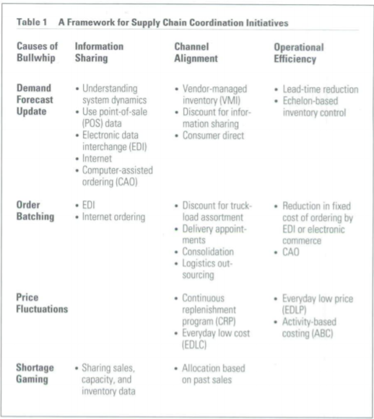
- Operational efficiency – activities which reduce costs and lead time, etc.

- Avoid multiple demand forecast updates – avoid multiple demand forecast updates, make demand data from downstream site available to upstream site so both sites can update forecasts w same raw data. This data is next-best thing to POS data from resellers stores.
  - More radical – upstream site could control resupply from upstream to downstream, based on the demand and inventory info at the downstream site. Downstream site becomes a passive partner, also known as VMI (used by P&G), or continuous replenishment programme (CRP).
  - Long resupply lead times aggravate the bullwhip effect, so operational efficiency improvements can reduce the highly variable demand. JIT replenishment mitigates the effect.
- Break order batches. Order batch happens because of high costs of placing an order. Electronic data interchange (EDI) reduces paperwork costs of generating an order. This can be extended to computer-assisted ordering (CAO).
  - Another reason for large order batches is transport economics. Manufactures can induce distributors to order assortments of different products, so they can order smaller batches of each product and still fill the truck.
    - P&G offering discounts to distributors willing to order mixed-SKU loads
    - Companies can also used third-party logistics companies to make small batch replenishments economical. These can consolidate loads from multiple suppliers located close to one another. Additional handling and admin costs, but these are outweighed by benefits.
- Stabilising prices by reducing frequency and level of wholesale price discounting is the simplest way to control the bullwhip effect.
- Eliminate gaming in shortage situations; when suppliers have a shortage, instead of allocating based on orders, it can allocate in proportion to past sales records. This method is used by GM.
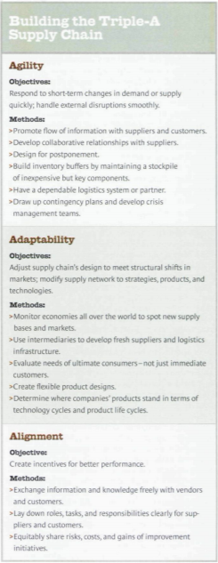
  - Another way to reduce gaming is manufacturers imposing penalties upon retailers for returning or cancelling orders.

Lee (2004) – The Triple A Supply Chain
- Best supply chains are adaptable, agile and ensure their companies’ interests remain aligned
  - Companies whose supply chains became more efficient and cost-effective didn’t gain a sustainable advantage over their rivals.
  - Agile – react speedily to sudden changes in demand or supply
  - Adaptable – adapt as market structures and strategies evolve
  - Align the interests of all firms in the supply network so that companies optimise the chain’s performance when they maximise their own interests

Drawbacks of efficiency
- High-speed, low-cost chains are less agile wrt to supply and demand. Centralising manufacturing and distribution facilities generates scale economies, but means they deliver only container loads to customers. Less able to respond to demand changes
  - Obsession w speed and cost damaging for new product launches – not holding a buffer stock means vendors have to ramp production up and down in line with demand surges, thus don’t have time to fix defects in the products.
- Also issues where the supply chains can’t adapt to changing market structures. Supply chain efficiency is necessary but insufficient to create a comp advantage

Agility in supply chains
- Objective: respond to supply and demand changes quickly, and handle disruptions smoothly. Methods:
  - Promote info flows with supplier and customers
  - Develop collaborative relationships with suppliers
  - Build inventory buffers of important but inexpensive components
  - Contingency plans, crisis management teams, design for postponement
- H&M and Zara have differentiated themselves from rivals by building agility into each link of their supply chains.
  - Zara case study – finalising designs last minute, can meet consumer tastes with minimum discounting or waste, superefficient distribution centres, state-of-the-art sorting and material handling. This ensures that distribution doesn’t become a bottleneck when demand fluctuates.
- Agility becoming more critical as shocks to supply chains become more frequent – threat from natural disasters, terrorism, epidemics and computer viruses has intensified due to climate change and the globalisation of supply chains.
  - Agile supply chains recover more quickly from these setbacks. After an earthquake in Taiwan (1999), Dell changed the prices of PC configurations overnight to steer demand way from hardware built with components which weren’t available. Dell quickly got data on the earthquake damage and vendors’ problems
- Agile supply chains can be developed by using 6 rules of thumb:
  - Provide data on changes in supply and demand to partners continuously so they can respond quickly. All firms have the same data at the same time, so can respond in a concerted fashion; no information delays facilitates an agile supply chain.
  - Develop collaborative relationships w customers and suppliers so they work together to design processes, components and products etc.
    - TSMC gives suppliers and customers proprietary tools and data so they can execute design and engineering changes quickly and accurately
  - Design products so the product mix shares common parts and processes until as late as possible in the production process – postponement or delayed differentiation. This allows quick response to demand fluctuation, waiting for accurate information.
  - Keep a small buffer of inexpensive components (e.g. Zara keeps zippers and hooks)
  - Build a dependable logistics system to enable quick response to changes, can be done whether investing yourself or through alliances with third-party providers.

Adaptable supply chains
- As well as unexpected changes in demand and supply, firms have near-permanent changes in markets. These structural changes occur due to economic progress, political and social changes, demographic trends, technological advances.
  - Best supply chains identify structural shifts before or as they occur by capturing latest data and tracking key patterns.
  - They then relocate facilities, change suppliers and may outsource manufacturing
- Adaptation isn’t only a defensive tactic – can help with new products and markets
  - Microsoft launched the Xbox from facilities in Hungary and Mexico as they beloved speed to market and technical support would be crucial for a successful launch, and these places were close to USA and European markets. This enabled a strong challenge to the market leader Sony, who responded by deep discounts
    - So costs became more important than speed, so the chain moved to China
- Supply chains should be tailored to the nature of the product’s market – this can result in multiple supply chains per company, which is expensive but gives the best manufacturing and distribution capabilities for each offering.
  - For example Gap’s three-pronged strategy incurs higher overheads and lower scale economies, but the 3 chains act as backups in emergencies, and allow the firm to maintain distinctive positions in different segments:
    - Old Navy brand for cost-conscious consumers sourced in China for cost-efficiency
    - Gap line for trendy buyers based in Central America for speed and flexibility
    - Banana Republic for higher quality based in Italy to maintain quality
    - This means
  - Sometimes difficult to define the market when launching an innovative product – can be done by considering level of technology and stage in its life cycle. Making these characteristics clear to supply chain partners enables optimisation.
    - Example is Toyota and its Prius hybrid launch in 2000.
- Building an adaptable supply chain requires three components:
  - Track economic changes, especially in developing countries which often create opportunities for outsourcing as they specialise.
  - Decipher the needs of end consumer as well as immediate consumers, otherwise the bullwhip effect may occur. Example is semi-conductor market in 2003.
  - Retaining the option to alter supply chains by developing new suppliers that complement existing ones, and ensuring product design teams are aware of the supply chain implications of their designs.
    - 3 principles of design-for supply are commonality, postponement and standardisation.

Alignment in supply chains
- Aligning the interest of firms in your supply chain with your own is important because every firm (assembler, distributor, retailer) maximises its own interest. If there is no alignment, their actions will not maximise the chain’s performance and value to customer. Lack of alignment causes the failure of many supply chain practices:
  - D
- Alignment can be achieved by redefining relationships in a way that makes firms share risks, costs and rewards equitably, e.g. RR Donnelley offered to split resulting savings from process improvements with suppliers, thus incentivising supplier-initiated improvements
- Sometimes alignment involves intermediaries
  - VMI – vendor-managed inventory systems where vendors maintain just enough stock to meet manufacturer’s needs and replenish hubs without waiting for orders

Shih (2020) – Increasing supply chain resilience post-Covid
- Demand and supply shocks caused by covid restrictions, coupled with the US-China trade war, has sparked economic nationalism. This may increase pressures on manufacturers to increase domestic production, reduce reliance on sources perceived as risky, and rethink lean manufacturing practices.
  - However customers will still want low prices (recession) and firms won’t be able to charge more and pressure to use capital and frugally will remain.
- Covid exposed hidden weaknesses which companies had failed to address – thoroughly mapping the supply chain will uncover risks which can then be mitigated against.
To increase resiliency without weakening competitiveness requires several steps:

Uncover and address hidden risks
- Manufacturers using specialised inputs turn to suppliers who narrowly focus in one area and these specialists in turn rely on many others. Creates significant disruption risks where you depend on a single supplier deep in your network for a crucial component, which is produced in only one plant or country.
Key ways to do so:
- Identify your vulnerabilities – go beyond the first and second tiers, map the full supply chain. Firms just focus on direct suppliers to save money and time, but disruptions are more costly
  - Mapping process should categorise suppliers as low, medium and high risk. This can be done via impact on revenues if a source is lost, time taken to recover from a disruption, availability of alternatives.
- Diversify your supply base: reduce heavy dependence on a high or medium risk source by adding more sources in locations not vulnerable to the same risks. US-China trade war has motivated a “China plus one” strategy, and regionwide problems (2004 Tsunami) argue for even broader geographic diversification.
  - Regional strategy of producing a substantial proportion of key goods within the region of consumption e.g. for USA, shifting from China to Mexico.
- Hold safety stock (intermediate inventory) – determine how much extra stock to hold in the interim, in what form, and where in the value chain. Cost-savings from JIT must be weighed against the costs of a disruption e.g. lost revenues and higher input prices for materials suddenly in short supply.

Take advantage of process innovations
- Relocating supply chains raises question of whether to bring production back inhouse or bring suppliers with them. Both options are opportunities to make major process improvements – unfreeze organisational routines and revisit process assumptions. New tech will allow companies to lower costs and increase flexibility:
  - Automation – social distancing accelerating move toward automation. This encourages a return of off-shore production to higher-cost countries
  - New processing technologies – e.g. latest chem manufacturing equipment uses less energy, produces less waste and is less capital intensive.
  - Continuous flow manufacturing can significantly increase supply chain resilience by reducing dependence on important active pharmaceutical ingredients (APIs).
  - Additive manufacturing (3D printing) can lessen dependence on distant suppliers

Keim (2013) – Secret life of everything
- Vast web of supply relationships, with intricate eco-systems, allow products to be assembled from inputs from all over the world.
  - Supply chains don’t just transport components, they also synchronise movements with algorithms optimising shipping networks, the path of pallets through warehouses etc
  - From a certain perspective, the actual products matter less than the informational structure that guides them.
- Factories where products are made are simply the meeting points for Tier 1 suppliers. The level of planning which allows variability includes all suppliers, not just tier 1.
- Key takeaway is its almost impossible to know where our products come from.

Liker and Choi (2004) – deep supplier relationships
- 100 biggest US manufacturers spent 48% of total on materials in 2002, vs 43% in 1996 (Purchasing magazine). Businesses increasingly rely on suppliers to reduce costs, improve quality, speed and develop new processes.
  - Experts agree corporations should build supplier keiretsu: close-knit networks of vendors that continuously learn, improve and prosper with parent companies.
    - Toyota and Honda have developed these supplier webs in the USA, therefore enjoying strong supplier relations, fast product development, lower costs and quality improvements. Data on this in the article.
- Toyota and Honda have built supplier relationships by following 6 steps:
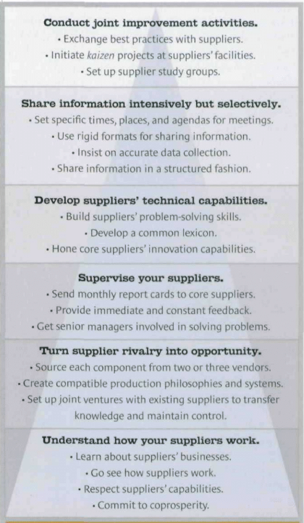
  - Understand how suppliers work
  - Turn supplier rivalry into opportunity
  - Supervise vendors
  - Develop vendors’ technical capabilities
  - Share information intensively but selectively
  - Conduct joint improvement activities
- These steps are mutually reinforcing, so can be built into a pyramid model called the supplier-partnering hierarchy.

- Understand how suppliers work – Toyota uses genchi genbutsu to send executive to see and understand for themselves how suppliers work. Managers at all levels study suppliers.
  - Japanese companies typically work backwards when setting prices for the inputs they buy – they start with the price of the product the market can bear, then figure out the costs they can incur to make the desire profits.
- Turn supplier rivalry into opportunity. Toyota and Honda use keiretsu system to develop 2-3 suppliers for every component, avoiding being locked into higher prices or technological compromises, and increasing resilience. They may have less sources than Americans, but they encourage vendor competition.
  - However Americans set vendors against each other and deal with last supplier standing, whereas Toyota and Honda only do so w support of existing suppliers, and uses this competition as an opp to cement relationships.
- Supervise suppliers. Role too vital for hands-off approach, use systems to measure performance and set targets.
  - Honda uses report card to monitor core suppliers (which can include third tier vendors) – monthly reports instead of annual, six sections including quality, incident report, quantity delivered and comments.
    - If any quality or delivery targets are missed Honda scrutinises suppliers to find the causes, how long it will take, and possible solutions.
    - If suppliers cannot identify cause, Honda will send teams to help them
- Develop compatible technical capabilities. Suppliers’ innovation capabilities seen as more important than wage costs, hence neither firm has switched to Chinese or Indian suppliers. Both invest heavily in first-tier suppliers to facilitate innovation.
  - Guest engineer programmes where suppliers’ engineers work alongside parent company for several years to understand development process and come up with design ideas for the firm.
  - They demand data from suppliers, which American suppliers don’t have as their manufacturers simply don’t demand it.
- Share info intensively but selectively. Can’t bombard suppliers w info, has to be structured with agendas, times and places, and correct formats. Components divided into those developed at Toyota and those developed at the vendor.
- Conduct joint improvement activities. Kaizen events at suppliers’ facilities, implement extensive development programmes and aim to create open communication channels as well as technical consulting.

My thoughts
- Tension between holding some inventory to remain resilient re covid and minimising inventory to achieve lean supply chain management.

